TRADE OF
Pipefitting

PHASE 2

Module 4

Pipe Installation

UNIT: 3

Electricity on Site

Produced by

In cooperation with subject matter expert:

Finbar Smith

© SOLAS 2014
Table of Contents
Unit Objective 1
Learning Outcome 2
1.0 Introduction to Electricity 3
1.1 The Atom 3
1.2 Laws of Electric Charge 5
1.3 The Balanced and Unbalanced Atom 5
1.4 Conductors 6
1.5 Insulators 6
1.6 Electrical Current Flow 6
1.6 The Electrical Circuit 7
1.7 Electrical Circuit Analogy 8
1.8 Ohm’s Law 9
1.9 The Effects of an Electric Current 10
2.0 Electrical Safety on Site 12
2.1 Electrical Safety on Site 12
2.2 Electrical Hazard Identification 13
2.3 Electrical Safety Devices 16
3.0 Electrical Cables 17
3.1 Live Electrical Cables 17
3.2 Electrical Voltages 17
3.3 Cable Locating Device 18
3.4 Underground Electrical Cables 18
3.5 Overhead Electrical Cables 20
3.6 Armoured Electrical Cables 22
4.0 Portable Hand Power Tools 23
4.1 Safe use of Portable Hand Power Tools 23
4.2 Maintenance of Portable Power Tools 24
4.3 110V Power versus 220V Power Tools 24
4.4 Extension Cables for Power Tools 24
Exercises 26
Additional Resources 27

Unit Objective
There are six Units in Module 4. Unit 1 focuses on Introduction to Pipe Installation and Safety, Unit 2; Piping Services, Unit 3; Electricity on Site, Unit 4; Bracket Fabrication, Unit 5; Ancillary Piping Equipment and Unit 6; Piping system assembly.
In this unit you will be introduced to the issues of electricity on site and the safety precautions required when working with electrical equipment or close to electrical wiring or installations.

Module 4

Pipe Installation
Unit 1

Introduction to Pipe installation and Safety
Unit 2

Piping Services
Unit 3

Electricity on Site
Unit 4

Bracket Fabrication
Unit 5

Ancillary Piping Equipment
Unit 6

Piping System Assembly

Learning Outcome
By the end of this unit each apprentice will be able to:
- Identify the basics of electricity
- Identify the basics of an electrical circuit
- Identify Ohm’s law
- Identify the effects of electrical current
- Identify and describe the key safety concerns associated with electricity on site.
- Recognise that all cables are potentially live until verified otherwise.
- Identify the differences between: 110V power, 220V power, 440V power and examples of where the different voltages are required.
- Demonstrate the use of a cable locating device.
- Identify possible hazards when working close to overhead power lines.
- Explain why and where armoured cables are used for wiring.
- Outline key safety pre-checks when working with power tools on site.
- Explain why portable power tools that are used on site are 110V.
- Describe the hazards of straining the cable of a power tool when in use.
- Recognise the importance of disconnecting power tools and equipment from mains prior to maintenance.

1.0 Introduction to Electricity

Key Learning Points
- Identify the basics of electricity
- Identify the basics of an electrical circuit
- Identify Ohm’s law
- Identify the effects of electrical current

1.1 The Atom
All matter is composed of atoms. An atom is the basic building block of matter. There are different types of atoms, but all atoms are extremely small. Atoms are made up of smaller particles called Protons, Neutrons and Electrons.

Definitions
- Atom: The smallest portion of a material that still exhibits all the characteristics of that material.
- Proton: The Proton has a Positive (+) charge of electricity. It is situated in the nucleus (or core ) of the atom.
- Neutron: The Neutron is electrically Neutral. It is also situated in the nucleus of the atom.
- Electron: The Electron has a Negative (-) charge of electricity. Electrons orbit the nucleus of the atom at great speed.

Simplified Representation of Atoms
The models of three different atoms are shown in Figures 1a, 1b and 1c. They illustrate how the electron(s) are arranged around the nucleus.
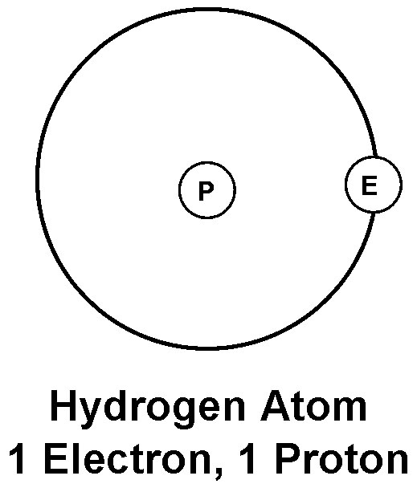
The simplest atom of all - the Hydrogen atom, consists of a single electron orbiting a nucleus, which, is composed of a single proton.
Figure 1a – The Hydrogen Atom

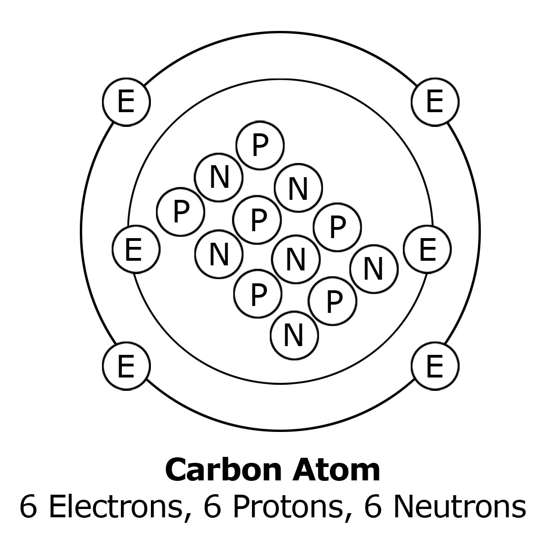
The carbon atom consists of, 6 electrons orbiting a nucleus of 6 protons and 6 neutrons.
Figure 2b – The Carbon Atom
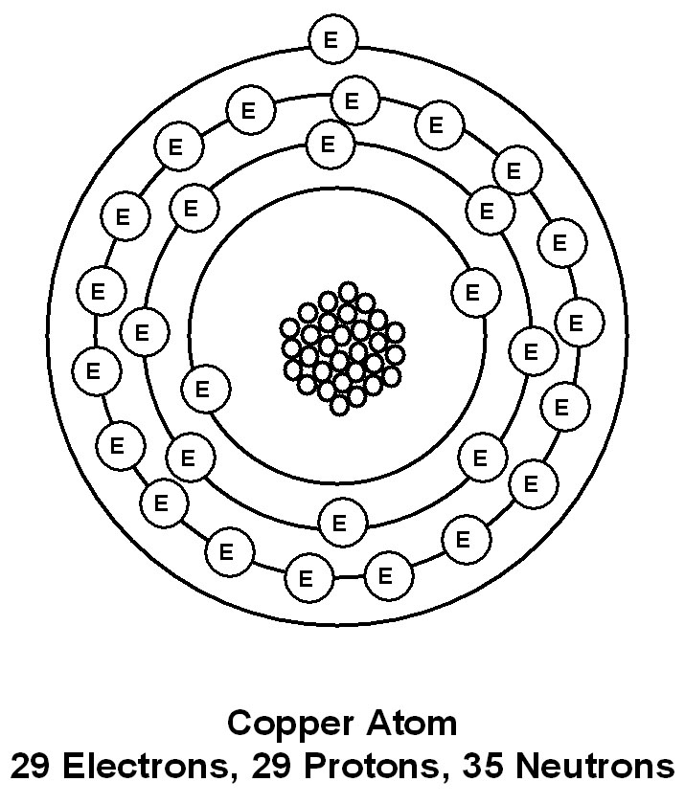
The copper atom consists of, 29 electrons orbiting a nucleus of 29 protons and 35 neutrons.
Figure 3c – The Copper Atom
Electrons orbit the nucleus of the atom in shells. The inner shell cannot have any more than two electrons. The copper atom has four shells. The outer shell is known as the valence shell. The electrons in the outer shell are more easily dislodged from the atom than the electrons in the inner shells. An atom cannot have more than eight electrons in its outer or valence shell.

1.2 Laws of Electric Charge
There are basic laws of nature, which describes the action of electric charges. These laws state:
- Like charges repel each other
- Unlike charges attract each other.
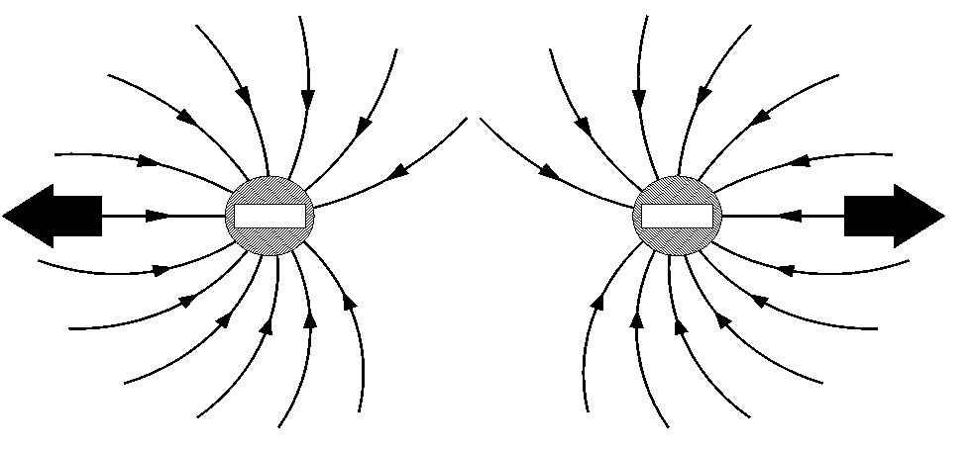
Figures 2a, 2b and 2c illustrate how negative and positive charges behave in relation to each other.
Figure 2a – Two negative electrons repel
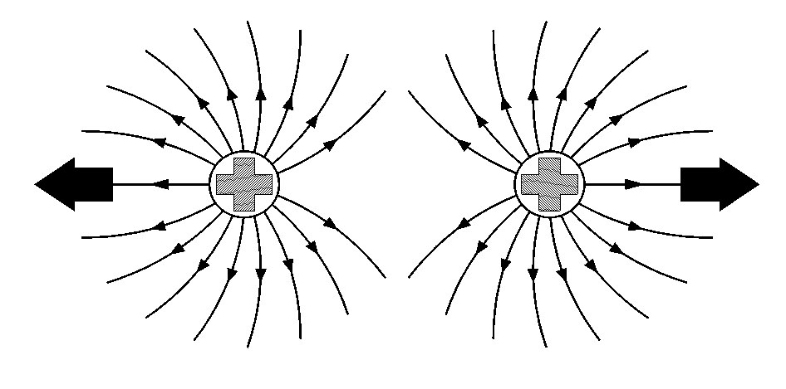
Figure 2b – Two positive protons repel
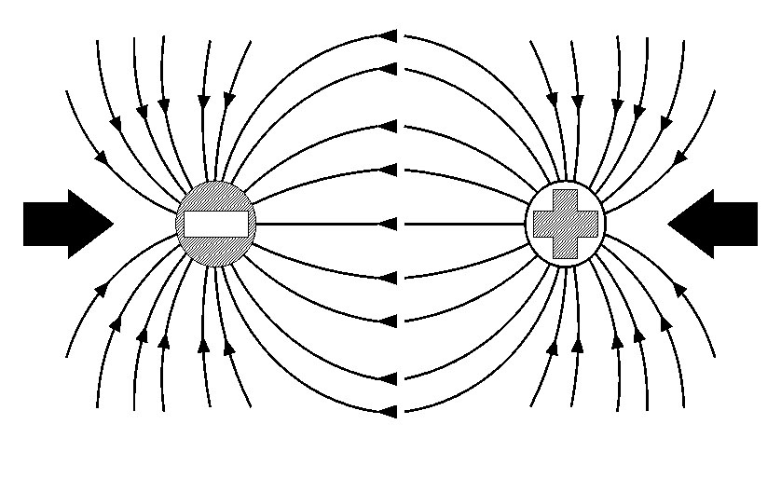
Figure 2c – An electron and a proton attract

1.3 The Balanced and Unbalanced Atom
In the previously mentioned examples (hydrogen, carbon and copper ) you may have noticed that the number of electrons was always equal to the number of protons. This is normally true of any atom. When this is the case, the atom is said to be neutral, balanced or normal. However, external forces can upset this state.
An atom that has gained or lost one or more electrons is no longer balanced. An unbalanced atom is called an ion. The atom that has lost an electron has an overall Positive charge. The atom that has gained an electron has an overall Negative charge.

1.4 Conductors
In some materials the electrons in the outer shells are easily dislodged. They can move from atom to atom inside the material. This movement of electrons is electric current flow. Materials, through which electric current can flow freely, are called conductors. Some typical conductors are copper, aluminium, brass, steel, silver and gold.

1.5 Insulators
In other materials the electrons are tightly bound to their own particular atoms. Electric current cannot flow freely through them. These materials are known as insulators. Some typical insulators are (Poly-Vinyl Chloride), PVC, rubber, plastic, glass, porcelain and magnesium oxide.

1.6 Electrical Current Flow
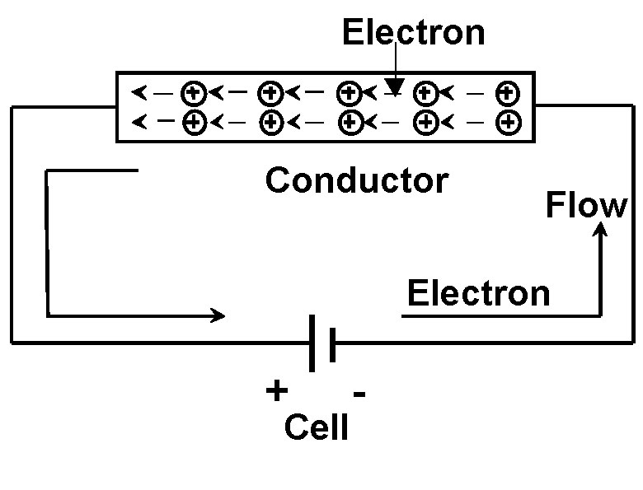
Electric current is the movement of free electrons. These electrons have a negative charge and are attracted to a positive charge. When the terminals of a cell are connected via a conductor as shown in Figure 3, free electrons drift purposefully in one direction only. This flow of current, is known as Direct Current (DC).
Figure 3– Flow of negative electrons from negative to positive
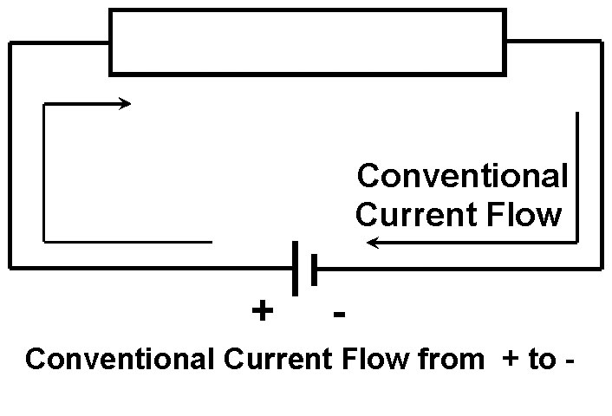
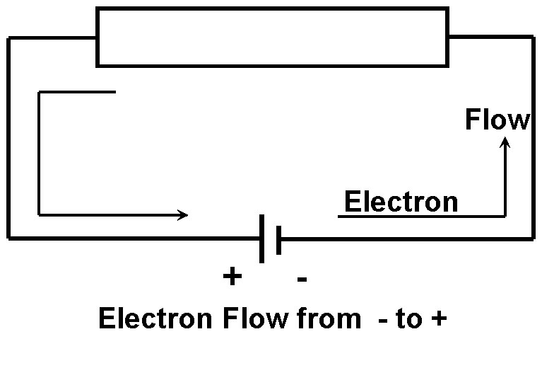
The electrons close to the positive plate of the cell are attracted to it. Each electron that enters the positive plate causes an electron to leave the negative plate and move through the conductor. The number of electrons in the conductor remains constant. The movement of electrons through a conductor is from negative to positive. Long before this theory was discovered, it was thought that current flowed from positive to negative. This direction of current flow is called conventional current flow. Figure 4 below illustrates the difference between the flow of electrons and the flow of conventional current.
Figure 4– Difference between the flow of electrons and the flow of conventional current
This movement of electrons through a conductor is known as an electric current and is measured in Amperes.

1.6 The Electrical Circuit
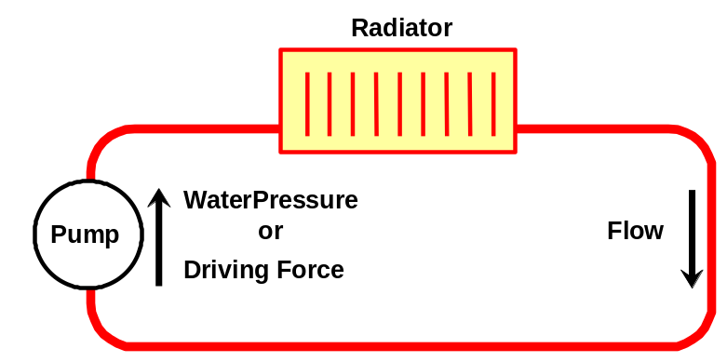
For continuous current flow, there must be a complete circuit. If the circuit is broken, by opening a switch for example, electron movement and therefore the current will stop immediately. To cause a current to flow through a circuit, a driving force is required, just as a circulating pump is required to drive water around a central heating system. Figure 5 below illustrates a conventional liquid circuit.
Figure 5– Conventional liquid circuit
This driving force is the electromotive force (abbreviated to EMF). It is the energy, which causes current to flow through a circuit. Each time an electron passes through the source of EMF, more energy is provided to keep it moving. See Figure 5 below which has the main components for a typical electrical circuit.
- A source of supply Electro Motive Force EMF (battery).
- A load (Lamp).
- Connecting cables (Conductors or wires).
- Switch for circuit control
- Fuse for circuit protection
Fuse
Switch
Load
Circuit
Control
Cell
Circuit
Protection
Source
of
supply
e.g. Lamp
Figure 5– Conventional electrical circuit
- The source of supply is always associated with energy conversion.
  - Generator ( converts mechanical energy to electrical energy )
  - Cell or Battery ( converts chemical energy to electrical energy )
The source of supply will provide pressure called Electromotive Force or Voltage. The symbol for voltage is U.
- The load is any device that is placed in the electrical circuit that produces an effect when an electric current flows through it. When an electric current flows through an incandescent lamp, the lamp gives off light from heat.
- The connecting leads or cables complete the circuit. The cable consists of the conductor to carry the current and insulation to prevent leakage. A water pipe must have a bore to carry the water and the pipe material ( e.g. copper ) to prevent leakage.
- A switch is fitted to turn the supply on or off. This is called the circuit control.
- One of the basic requirements that a circuit must have is over current protection. This is essential for protection of the cables and accessories in the circuit. A fuse or circuit breaker is used to provide this protection. It is fitted as close to the origin of the circuit as possible to cut off the supply if too much current flows in the circuit. This is called circuit protection.

1.7 Electrical Circuit Analogy
The simplest analogy of an electric circuit is to consider a hosepipe connected to a tap. The rate of flow of water from the end of the hosepipe will depend upon:
- The water pressure at the tap.
- The diameter of the hosepipe
- The restriction / resistance of the inner walls of the hosepipe.
- The degree of any bends or kinks in the hosepipe.
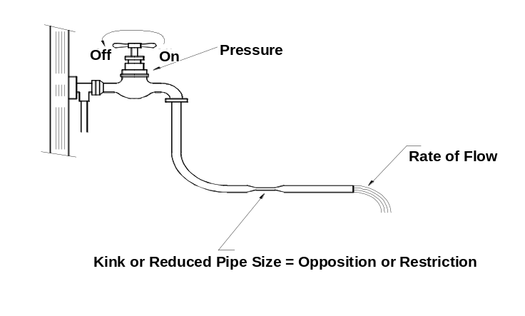
If there are many restrictions, the water will flow out of the hosepipe at a reduced rate.
Figure 6– Water circuit as an analogy for an electrical circuit
In much the same way, current flows through conductors by means of electric pressure provided by a battery or generating source. This source of electric pressure, electromotive force (EMF ), provides the energy required to push current through the circuit. It can be referred to as the supply voltage.
Every circuit offers some opposition or restriction to current flow, which is called circuit resistance. The unit of resistance is the Ohm, symbol Ω, pronounced Omega. At this stage, conductor resistance is ignored and the load resistance is treated as the total opposition to current flow.
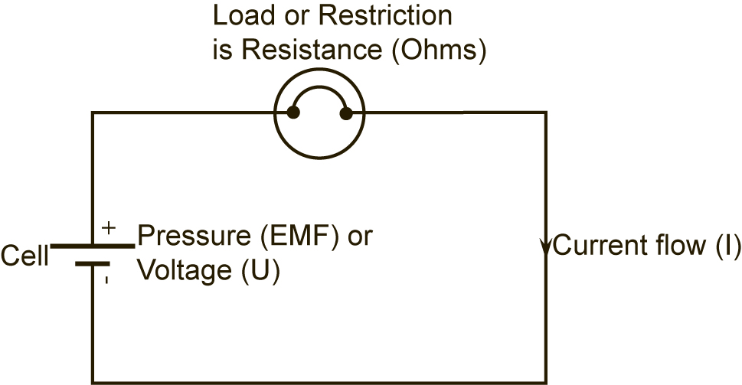
For a stable supply voltage, the current (I) which flows, is determined by resistance (R) of the circuit. There will be a voltage drop across different parts of the circuit and this is called Potential Difference (PD).
Figure 7–electrical circuit
Unlike the hosepipe analogy, the electric circuit requires a “go” and “return” conductor to form a closed loop or complete circuit. These conductors must offer a low resistance path to the flow of current. Most metallic conductors satisfy this requirement.

1.8 Ohm’s Law
George Ohm discovered the relationship between, current flowing in a circuit and the pressure applied across that circuit. This became known as Ohm’s Law.
Ohm’s Law states that the current (I) flowing through a circuit is directly proportional to the potential difference (U), across that circuit, and inversely proportional to the resistance (R), of that circuit, provided the temperature remains constant.
U
R
I =

To find U, transpose the formula by multiplying both sides of the equation by R.
U
R
I=

I x R = ———
U x R
R

U x R
R
I x R = ———

I x R = U

or:
U = I x R

1.9 The Effects of an Electric Current
When an electric current flows in a circuit it can have one or more of the following effects:
- Heating Effect
- Magnetic Effect
- Chemical Effect

The Heating Effect
The movement of electrons in a circuit, which is the flow of an electric current, causes an increase in the temperature of the load resistance. The huge number of electrons being pushed through the load resistance, results in high friction and collision of these electrons. This generates heat. The amount of heat generated depends upon the type and dimensions of the load resistance wire and the value of current flowing. By changing these variables, a length of resistance wire may be operated at different temperatures to give different effects, e.g. an ordinary light bulb or an electric heater.
Figure 8–The heating effect of electrical current
Cell
Load Resistance
(Heater or Bulb)
Fuse
MCB
Switch

The Magnetic Effect
Whenever a current flows in a conductor a magnetic field is set up around that conductor.
Direction
of
Current Flow
Switch
Magnetic field lines
Figure 9–The magnetic effect of electrical current
This magnetic field increases in strength if the current is increased and collapses if the current is switched off. A “current carrying conductor”, wound in the form of a solenoid ( coil ), produces a magnetic field very similar to that of a permanent magnet, but has the advantage in that it can be switched on or off by any switch controlling the circuit current. The magnetic effect of an electric current is the principle upon which electric bells, relays, moving coil instruments, motors and generators work.

The Chemical Effect
When an electric current flows through an electrolyte (conducting liquid / paste), this electrolyte is separated into chemical parts. The two conductors, which make contact with the electrolyte, are called the anode (positive plate) and the cathode (negative plate). An anode or cathode of dissimilar metals placed in an electrolyte can react chemically and produce an EMF. When a load is connected across the anode and cathode, a current will flow in the circuit. The chemical effect of an electric current is the principle upon which electric battery operates.
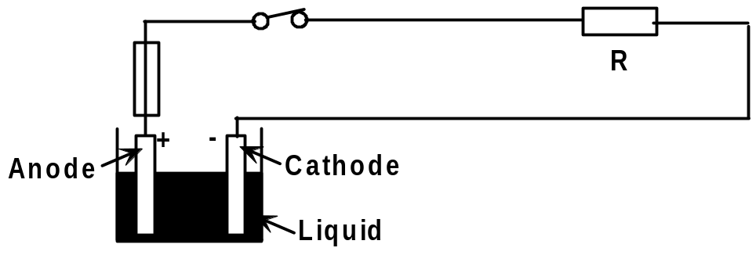
Figure 10–The chemical effect of electrical current

2.0 Electrical Safety on Site

Key Learning Points
- Identify the key safety concerns associated with electricity on site
- Identify how to mitigate these safety concerns

2.1 Electrical Safety on Site
Electricity is widely recognized as a potential workplace hazard, exposing employees to electric shock, burns, fires and explosions. Working on or around electrical conductors and equipment can be particularly dangerous, because electrical energy often cannot be sensed until contact is made. The following guidelines should be applied to every workday:
On a daily basis, before starting any task, inspect the work area for possible electrical hazards. Take all necessary precautions to avoid cutting into electrical lines. In work areas where the exact location of the electrical power is unknown, power in the general vicinity of the building should be de-energized.
Operators should wear proper dielectric safety footwear and rubber insulating gloves. Instruct each employee on how to recognize and avoid unsafe conditions that apply to the work areas.
Shut off the main power source when working on anything electrical, such as switches and outlets. Follow lockout/tagout procedures. Never overload a circuit by plugging too many items into one outlet.
Assure proper grounding of all electrical equipment. Use equipment that provides a permanent and continuous path from circuits, equipment, structures, conduit or enclosures to ground and ensure that proper safety trip switches are fitted.
If working near high voltage lines, operators must maintain a safe working distance—a minimum distance of 3 meters (50 kV line or less) between their equipment and the electrical distribution or transmission lines. The higher the voltage line, the greater the distance that is required between the equipment and the line.
Only use 110V power tools and extension cables on site. If exceptional circumstances require the use of 220V equipment or cables then these should be armoured cables and use correct industrial safety plugs and sockets.
Inspect electrical tools and equipment daily. Remove defective or suspect equipment from use and tag “Do Not Use.” Make sure equipment is properly maintained.
Do not use worn or frayed electrical cords or any electrical cord with visible wires. Verify the ground plug is present and has not been damaged or modified.
Keep all cables and cords out of the path of travel and away from saw blades, core bits, air tools and keep them from being run over by equipment. Electrical cables in high traffic areas should be protected. Electrical cables should not be secured with staples, coat hangers, nails or wire. Keep all cables, tools and electrical connections dry.
Ensure all components, cables, plugs and twist locks are properly sized and not modified from their original specifications. If a cable is warm or hot to the touch, the cable is too small for the equipment being used. Use cables that are rated to carry the maximum current ratings of the motor being used. Larger cords are necessary when using longer stretches of cord.
Make sure that power tools are switched OFF before plugging them in. Shut off power whenever possible when connecting or disconnecting connectors. Verify that once connected, the cable is fully plugged in, secured and cannot be disconnected.
Do not pick up or carry a tool by its cord or hose. Do not unplug by pulling on the cable. Grasp plug body to remove or insert a cable from an outlet and never use excessive force.
Develop and maintain a safety and health program to provide guidance for safe operations. Proper maintenance and records will help ensure that all equipment is safe.

2.2 Electrical Hazard Identification
Identify the Hazard | Identify the risk | Action to minimise the risk
- Potential that power lines are live | - Electric shock, burns or electrocution. | - Ensure electrical isolation permit system in place.  - Ensure earth leakage switch is fitted on mains supply or portable generator.  - Use only licensed electrical contractors or authorised person to switch off/isolate power.  - Prevent power being switched back on, e.g. remove main fuse or tag and lock out method.  - Train on site labour to treat all power circuits as live.  - Irregular or unauthorized connections identified and disconnected.

- Power sited too far from work area. | - Electric shock, burns or electrocution.  - Trip accidents. | - Ensure the electrical supply provided is within the maximum length allowable for the rating of the extension lead used  - Avoid using several extension leads connected together (in series).  - Ensure insulated hooks are used – avoid leads being wrapped around metal components, e.g., formwork.  - Avoid power leads run between floors.  - Ensure leads are not severed by sharp edges.  - Ensure extension leads are secured above work area and not lying in water or other liquid.
- Short circuit resulting in an electrical fire. | - Electrical fire, burns and/or contact with electricity. | - Ensure correct type of fire extinguisher is available i.e. powder or CO2 not water.  - Personnel should be trained in the use of fire fighting equipment.  - Extinguisher positioned at fire source e.g. base of switchboard.
- Use of power tools and/or electrical plant. | - Electric shock, burns or electrocution. | - Ensure earth leakage switch is fitted on mains supply or portable generator.  - Ensure power cables are kept tidy and that they cannot be severed by power tool blade.  - Ensure tools are double insulated – no old metal types.  - Ensure tools are not placed in or near water.

- Underground electrical services. | - Strike underground cabling with machine, hand tool or other. | - Ensure drawings are correct, and check that services are in their expected location.  - Ensure that excavation permit to dig system is in place and followed.  - Locate underground services and/or isolate them.  - Cables should be exposed by hand before digging using plant.
- Power lines near the site and power to the site. | - Strike and knock overhead power lines with ladder, scaffold or machine plants.  - Electric shock, burns or electrocution. | - Get power lines isolated by the Supply Authority where possible.  - Power lines not covered or enclosed.  - Ensure machine operating at a safe working distance to power lines.  - Use a spotter to supervise machines operating near power lines.  - Erect barriers and goalposts where machines have to pass beneath lines.
- Inappropriate electrical lighting to work area. | - Trip accidents.  - Electric shock, burns or electrocution. | - Ensure adequate quantities of lighting are provided.  - Ensure lighting is protected with wire guards or diffuser.

2.3 Electrical Safety Devices
If equipment operating at 230 volts or higher is used, an RCD (residual current device) can provide additional safety. An RCD is a device which detects some, but not all, faults in the electrical system and rapidly switches off the supply. The best place for an RCD is built into the main switchboard or the socket-outlet, as this means that the supply cables are permanently protected. If this is not possible a plug incorporating an RCD, or a plug-in RCD adaptor, can also provide additional safety.
RCDs for protecting people have a rated tripping current (sensitivity) of not more than 30 milliamps (mA). Remember:
An RCD is a valuable safety device, never bypass it;
If the RCD trips, it is a sign there is a fault. Check the system before using it again;
If the RCD trips frequently and no fault can be found in the system, consult the manufacturer of the RCD;
The RCD has a test button to check that its mechanism is free and functioning. Use this regularly.

3.0 Electrical Cables

Key Learning Points
- Treat all cables as live until verified otherwise.
- Identify the purpose of different electrical voltages
- Identify how cable locating device works
- Identify safety guidelines when operating close to underground cables.
- Identify safety guidelines when operating close to overhead cables.
- Identify the purpose of armoured cables

3.1 Live Electrical Cables
One of the most fundamental rules of electrical safety is to recognise that all cables are potentially live until verified otherwise. Personnel should treat all electrical circuits as "Live" until they have been tested tagged and locked out by a competent certified electrician. Conduct any work on the circuit only after determining that there is no voltage in any of the exposed circuits. If voltage is detected in any exposed circuit, STOP, inform supervisor and determine source and procedure to eliminate voltage.

3.2 Electrical Voltages
There are 3 main levels of voltage used for electrical equipment on sites, 110 volt power, 220 volt power and 440 volt or 3 phase power.
On a 110V system there is one positive wire a neutral wire and a ground. With a 220V there are 2 positive wires (hot wires) and a ground 220V is double volts compared to a 110V system. After 220V next is called 440V also known as a three phase supply. 110V is what most small power tools use and 220V is used for larger equipment such as welders or hot water heaters.
The reason for the two voltages is that some equipment, such as welders or a water heater, draws a lot of power. A water heater is typically 4400 watts. At 110V this would be 40 amps. That would take a wire of a large cross sectional area. At 220V, 4400 watts only takes 20 amps. You don't need as big a wire for the same power. The lower current is also a little safer as the potential heating in the wiring is reduced. This is also why most 110V AC appliances are limited to about 1200 to 1500 watts. 1200 watts on a 110V AC circuit is just under 11 amps. 1500 watts is just over 13.5 amps. Most domestic homes have 20 amp circuit breakers but older houses may have 15 amp breakers or fuses
Giving a device a lower voltage than it was designed for is generally not dangerous; the device may not work correctly, but no dramatic failure is likely. Giving any device a voltage higher than it was designed for is dangerous and will very likely damage the device. If you put 230 volts into a device designed for 110 it may melt, catch fire, or even explode.

3.3 Cable Locating Device
Location of underground services and cables is necessary because drawings often lack the pinpoint precision needed to ensure proper clearance for site excavations. Because many different types of materials go into manufacturing the different types of underground lines and services, different detection and location methods must be used. For metal pipes and cables, this is often done with electromagnetic equipment consisting of a transmitter and a receiver. For other types of pipe, such as plastic or concrete, other types of radiolocation or modern ground-penetrating radar must be used.
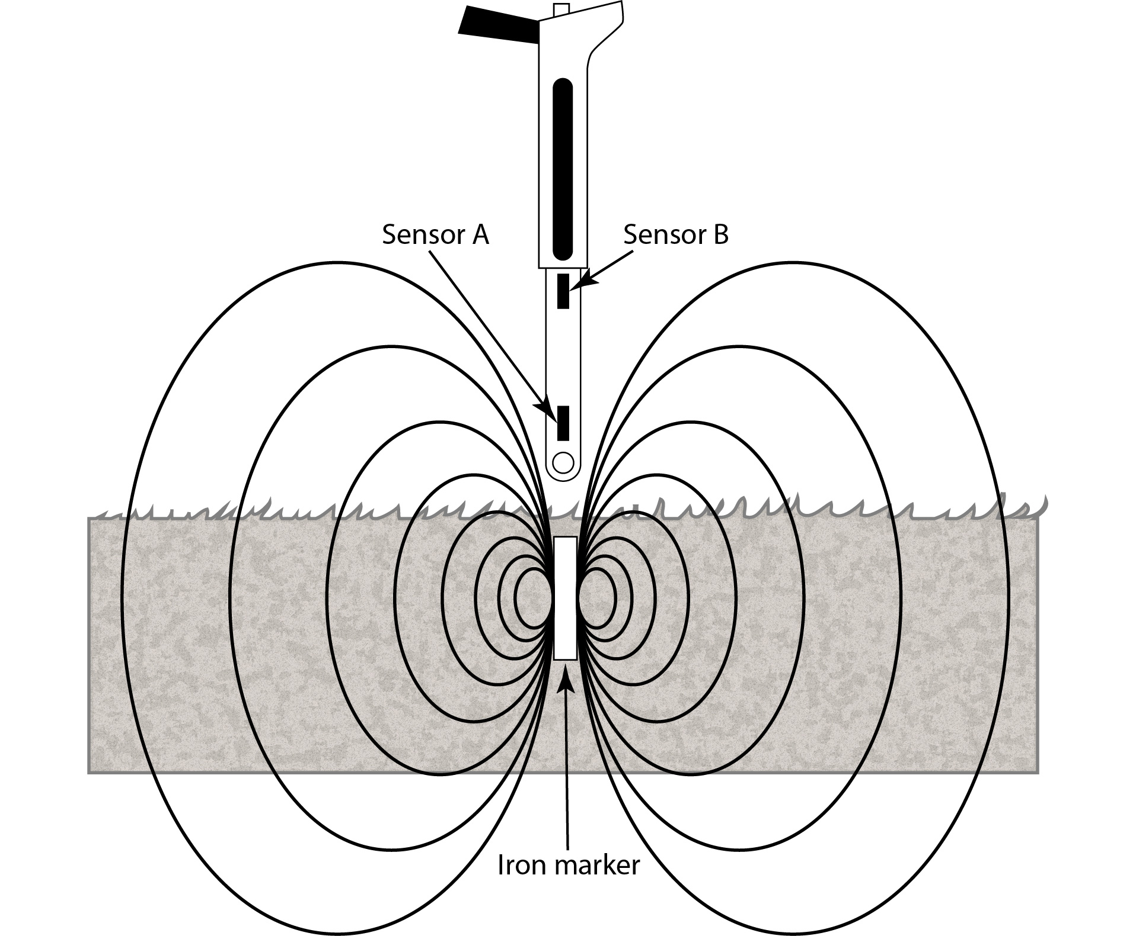

Underground cables can be pinpointed using a electromagnetic instrument as illustrated in figure 11 which can often provide depth and current readings based on electromagnetic signals that radiate from the buried cable.
Figure 11–Cable locating device
Electromagnetic locators detect the magnetic field of ferromagnetic objects. They respond to the difference in the magnetic field between two sensors that are spaced approximately 250mm apart. Some devices use only an audio tone which gets louder as you get closer while others also have a visual display which shows the signal polarity and a bar graph to help determine the targets orientation.

3.4 Underground Electrical Cables
Injuries resulting from damage to live electricity cables are usually caused by the explosive effects of arcing current, and by any associated fire or flames which may follow, when the sheath of a cable and the conductor insulation is penetrated by a sharp object such as the point of a tool. One of the main dangers which may arise when digging is that of possible injury from underground power cables. You should not commence any excavation until you have taken at minimum the following precautions:
- Correct use of Plans (to aid location of power cables) Before starting work it is essential that you have all of the cable records for the location and that these are kept on site at all times while work is proceeding. Make sure that they are up-to-date; that they cover all cable voltages at the location; that you understand how to interpret them; and that they are fully utilised both in advance of commencing digging and throughout the full duration of the work.
- Use of Cable Locating Devices, suitable cable locating devices should be used in conjunction with the cable plans to determine as accurately as possible the position of underground cables in or near the proposed work area.
- Use of Safe Digging Practice, including the following pointers:
- Wherever possible, hand dig near buried services
- Take special care using picks or insulated crowbars
- Wear insulated gloves and other appropriate PPE
- Do not use hand held power tools within 0.5m of marked positions of electricity cables unless the number of services makes it impossible or surface obstructions reduce the space available.
- Before using a mechanical excavator in the vicinity of electricity cables, trial holes should first be excavated by careful hand digging. Confirm the depth of the cables at the point of work. The excavator should not be operated within a radial distance of 300mm from the cables.
- When using a mechanical excavator ensure that all personnel are kept clear of the bucket and excavator while it is digging.
- Where electrical cables are embedded in concrete, arrange for the cable to be switched out before breaking concrete.
- If an electric cable has been damaged, inform the owner immediately and keep the area clear until it has been made safe.
- Backfill around services with sand and use appropriate utility warning marker tape.

3.5 Overhead Electrical Cables


People are killed and injured each year by accidental contact or near contact with overhead electricity lines. Most of these accidents occur when there is contact or near contact with overhead lines by cranes or excavators, by tipping trucks or truck mounted cranes, by mobile extendable machinery, or by metal equipment such as scaffolding, metal gutters, long metal handled concrete floats or metal ladders. Such accidents can be prevented by taking all practicable precautions to prevent accidental contact or near contact - which may cause electrical arcing from the overhead line.
Figure 12–Hazard from overhead cables and the method employed to eliminate the risk
When working in the vicinity of overhead power lines the following safety guidelines should be observed:
- Develop and implement written safety programs to help workers recognize and control the hazards of contact with overhead power lines.
- Conduct initial and daily surveys of the worksite and implement control measures and training to address hazards at the site.
- Keep a safe distance between yourself and power lines. 3 metres is generally considered the minimum safe distance. Always consider all power lines as energized and dangerous.
- A successful defense against electrical accidents is the continuous exercising of good judgment or common sense. All employees should be thoroughly familiar with the safety procedures for their particular jobs. When work is performed on electrical equipment, for example, some basic procedures are:
- Have the equipment de-energized.
- Ensure that the equipment remains de-energized by using some type of lockout and tag procedure.
- Use grounding lines when they are required.
- Use insulating equipment.
- Keep a safe distance from energized parts.
- Don't operate equipment around overhead power lines unless you are authorized and trained to do so.
- Look up before you unload or load a crane from a truck or lowboy. Make sure there are no overhead lines before you start.
- If an object (scaffolds, crane, etc.) must be moved in the area of overhead power lines, appoint a competent worker whose sole responsibility is to observe the clearance between the power lines and the object. Warn others if the minimum distance is not maintained.
- Never touch an overhead line if it has been brought down by machinery or has fallen. Never assume lines are dead.
- When a machine is in contact with an overhead line, DO NOT allow anyone to come near or touch the machine. Stay away from the machine and summon outside assistance.
- Be trained in cardiopulmonary resuscitation (CPR).
- When mechanical equipment is being operated near overhead power lines, employees standing on the ground may not contact the equipment unless it is located so that the required clearance cannot be violated even at the maximum reach of the equipment.
- To maximize his or her own safety, an employee should always use tools that work properly. Tools must be inspected before use and, those found questionable, removed from service and properly tagged. Tools and other equipment should be regularly maintained. Inadequate maintenance can cause equipment to deteriorate, resulting in an unsafe condition.
- Tools that are used by employees to handle energized conductors must be designed and constructed to withstand the voltages and stresses to which they are exposed.
- Use the personal protective equipment appropriate for the job that is performed. This equipment may consist of rubber insulating gloves, hoods, sleeves, matting, blankets, etc. These items must be inspected prior to each use and tested annually.
- When working near overhead power lines, the use of non-conductive wooden or fiberglass ladders is recommended. Aluminum ladders and metal scaffolds or frames are efficient conductors of electricity.
- Avoid storing materials under or near overhead power lines.

Emergency Action in the Event of an Accident
- Instruct everyone outside the vehicle not to approach or make contact with it.
- Never touch a person who is in contact with a live power line.
- If you should be in a vehicle that is in contact with an overhead power line, DON'T LEAVE THE VEHICLE. As long as you stay inside and avoid touching metal on the vehicle, you may avoid an electrical hazard. If you need to get out to summon help or because of fire, jump out without touching any wires or the machine, keep your feet together, and hop to safety.
- Never touch an overhead line - even if it has been brought down by machinery, or has fallen. Never assume lines are dead.
- When a machine is in contact with an overhead line, electrocution is possible if anyone touches both the machine and the ground. Stay in the machine and lower any raised parts in contact or drive the machine out of the lines if possible.
- Get the electricity company to disconnect the supply. Even if the line appears dead, do not touch it - automatic switching may reconnect the power.

3.6 Armoured Electrical Cables
Armoured cables, as the name suggest are the type of cables covered with a lot of protection. These armoured cables are covered with strong steel strands wrapped round the cable. They are usually used for transferring power either underground or overhead. Armoured cables are mostly used for burial wiring because the ordinary mains cable may be damaged by the hit of a spade or other sharp tools.
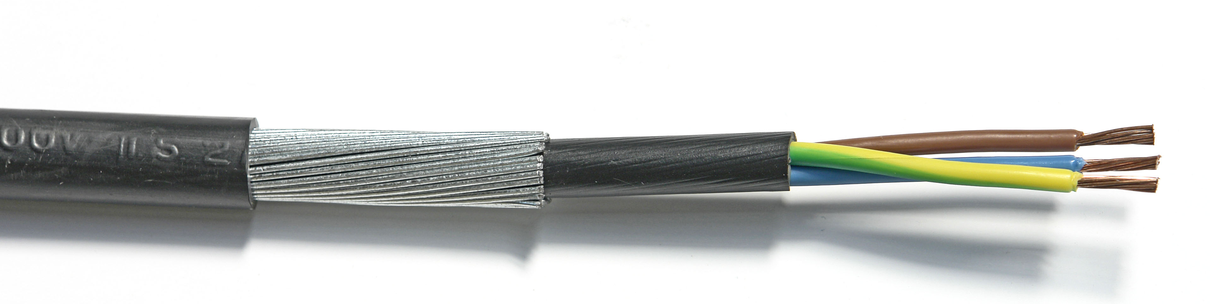
Figure 13–Structure of Armoured cable
Figure 13 shows the structure of armoured cable, the armoured cable is constructed of three layers of protection. The innermost core is generally multi strand and each one is individually sheathed from each other. There may be two, three, or four strands depending upon the application. Then an overall plastic sheath covers these individual strands altogether in a single unit. Further it is covered by protective wire armour. Finally there is an outer sheath to hold it. The three core cable - live, neutral and earth - is mostly used in domestic installations while the four core cable is used when there is a three phase supply is in use.

4.0 Portable Hand Power Tools

Key Learning Points
- Identify safety guidelines when using power tools
- Identify safety guidelines when maintaining power tools
- Identify why 110V power tool are used on construction sites
- Identify safety guidelines when using extension cables

4.1 Safe use of Portable Hand Power Tools
Power tools can be hazardous when improperly used. There are several types of power tools, based on the power source they use: electric, pneumatic, liquid fuel, hydraulic, and powder-actuated. Employees should be trained in the use of all tools - not just power tools. They should understand the potential hazards as well as the safety precautions to prevent those hazards from occurring. The following general precautions should be observed by power tool users:
- Outline key safety pre-checks when working with power tools on site.
- Use the tool only for its designed purpose.
- Read the Owner’s Manual and follow manufacturer’s safety instructions.
- Ensure the power switch is “OFF” before plugging or unplugging tools.
- Never carry a tool by the cord or hose.
- Never yank the cord or the hose to disconnect it from the receptacle.
- Unplug the cord before making adjustments, changing/replacing parts/accessories.
- All observers should be kept at a safe distance away from the work area.
- Secure work with clamps or a vise, freeing both hands to operate the tool.
- Avoid accidental starting. The worker should not hold a finger on the switch button while carrying a plugged-in tool.
- Be sure to keep good footing and maintain good balance.
- Don appropriate PPE. Loose clothing, ties, or jewelry can become caught in moving parts.
- Use of electric-powered tools with a RCDs will drastically reduce the possibility of electric shock or electrocution.
- Do not use electric-powered tools in damp or wet locations.
- All portable electric tools that are damaged shall be removed from use and tagged "Do Not Use."

4.2 Maintenance of Portable Power Tools
Only properly qualified and trained personnel should perform maintenance and electrical safety checks on portable power tools. However any personnel using portable power tools should at a minimum be aware of the following guidelines for safe use and basic maintenance of portable power tools:
- Power tools operate at very high speeds, so when things happen, they tend to happen fast. A sudden tool start-up after a voltage drop or power interruption can suddenly fling a work piece at the operator. Fingers may be drawn into a cutting blade, or the tool may move toward other body parts that are in the wrong place at the wrong time.
- Tools should be maintained with care. They should be kept sharp and clean for the best performance. Follow instructions in the user's manual for lubricating and changing accessories.
- If a tool is defective, remove it from service, and tag it clearly "Out of service for repair.
- Follow the manufacturer's recommendations for maintaining your power tools. Most metal tools should be lightly oiled and stored in a cool, dry place.
- Always unplug the tool when you change blades, bits or do minor repairs.
- Inspect tools before each use and replace or repair a tool if it is worn or damaged.
- Check safety guards, screws, nuts, bolts and movable parts to ensure they are tightened.

4.3 110V Power versus 220V Power Tools
The supply of 220V is fatal but a 110V supply is not. On building sites, a 110V power supply is provided using an isolating transformer to provide two 55volt lines out of phase. That means you can connect 110V equipment across them. If someone were to cut through the cable by accident, the worst shock they will get is 55volts which is very unlikely to be fatal.
The physical differences are the gauge of the cable and the number of windings on the motor. 220V equipment plugged into a 110V supply will run off load at roughly quarter speed and is likely to stall on load. 110V equipment plugged into a 220V supply tends to burn out.

4.4 Extension Cables for Power Tools
Where possible power tools should be plugged directly into wall sockets to minimize or eliminate the risks associated with extension cables. Where this is not possible the following guidelines should be observed when using extension cables.
- Inspect cords regularly. Look for signs of stretching, insulation damage, and kinking. Keep cords and cables clean and free from kinks. Kinking can damage both the cord's insulation and internal wire.
- If an extension cord is required, make sure it is for the correct wattage and has the proper plugs.
- Verify condition of the cord and plugs and check for rated use: indoor or outdoor.
- Keep the cord away from heat, oil/chemicals, sharp edges and ensure it doesn’t become a tripping hazard
- Pulling on electric cords can damage the cord insulation and cause electric sparks.
- Check insulated tools for damage before each use. Once the insulation layer of an insulated hand tool becomes nicked, cracked or cut, the tool is no longer effectively insulated – it actually becomes more of an electrical conductor, and can increase your risk of injury.
- Do not tie power cords in knots. Knots can cause short circuits and shocks. Loop the cords or use a twist lock plug.
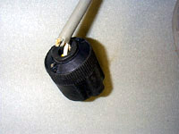
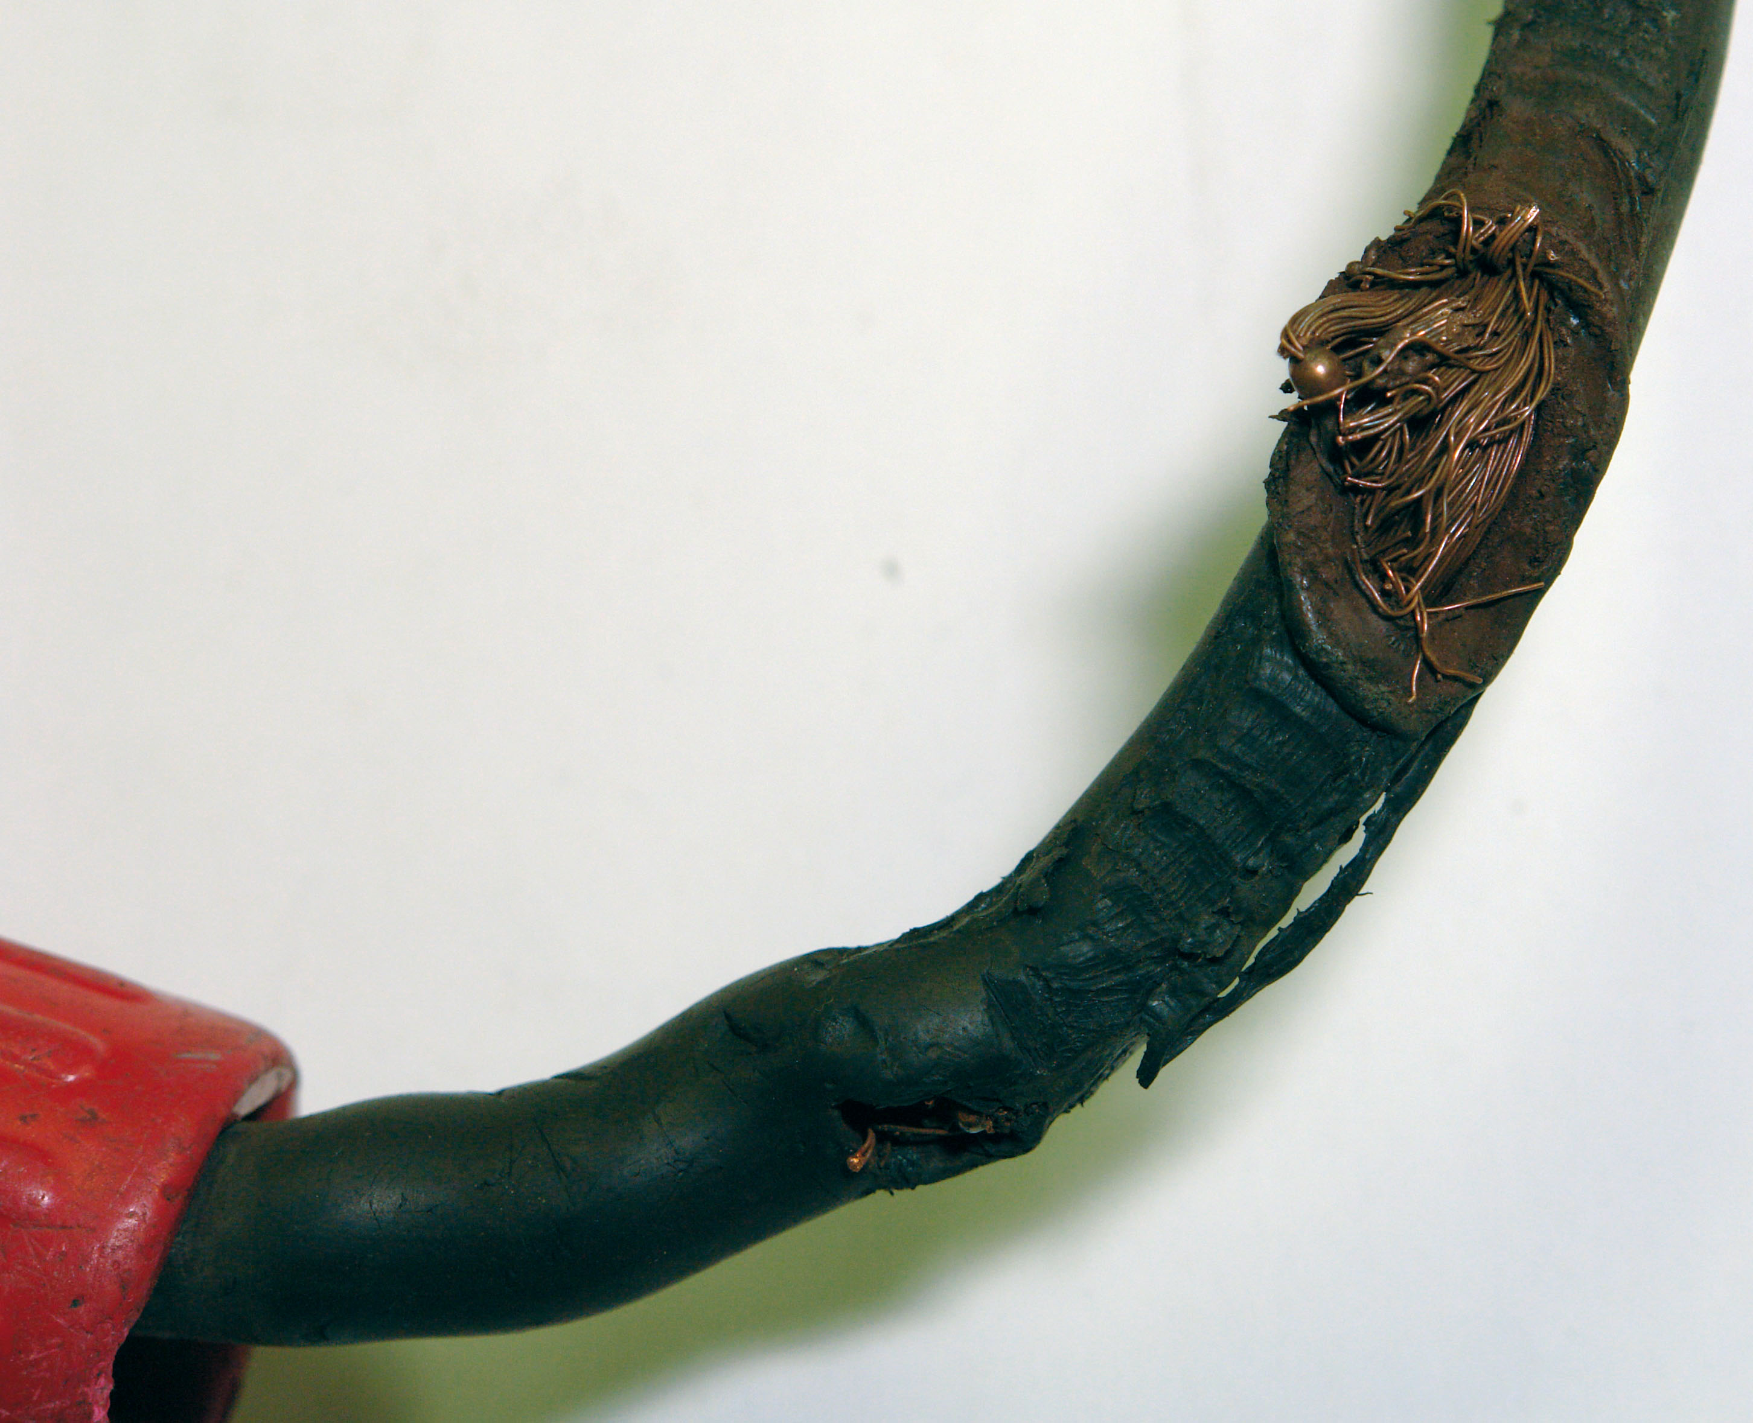
- Due to the fact that 220V power is lethal and should not be used on constructions sites, if an exception is made only armoured 220V cable should be used for extension cables.
Figure 14–Frayed cables and strained cables caused by inappropriate use

Exercises
- Identify four electrical hazards associated with working on site that would not be present in a workshop environment.
- Identify four hazards associated with overhead power lines and what actions can be taken to mitigate these hazards.
- Identify the 3 steps to be taken when excavating where power lines may be present.
- Name the 3 effects of electrical current and practical applications of these effects in the pipe fitting industry.
- Describe why 110V power tools are used on construction sites?
- Identify four hazards associated with portable power tools and what actions can be taken to mitigate these hazards.
- Identify four hazards associated with extension cables and what actions can be taken to mitigate these hazards.

Additional Resources
Title | Author | Ref. Code
The Induction Book, “Code of Behaviour & Health & Safety Guidelines” | SOLAS
Basic Welding and Fabrication | W Kenyon | ISBN 0-582-00536-L
Fundamentals of Fabrication and Welding Engineering | FJM Smith | ISBN 0-582-09799-1
Workshop processes, practices and materials, 3rd edition, Elsevier Science & Technology | Black, Bruce J 2004 | ISBN-13: 9780750660730
New Engineering Technology | Lawrence Smyth & Liam Hennessy | ISBN 086 1674480

Videos:
- Understanding welding fumes
- Welder on Site…Be Aware (Vocam)
- Powered hand tool safety (Vocam)
- Industrial Ergonomics (Vocam)
Available from:
Vocam Ireland
Circle Organisation Ltd
Friar Street, Thurles, Co Tipperary, Ireland
Tel: +353 504 24666

Castleforbes House
Castleforbes Road
Dublin 1

